Internet and Web Programming

CSE3002

Fall Semester 2020-21

Lab Assignment 11

**ISHAAN OHRI**

**18BCE0265**

**Question:**

Write a program to demonstrate the concept of data storage and parsing in XML

Develop a thesaurus tool by creating a schema for thesaurus. When a word is entered the synonyms or antonyms must be displayed based on the user request.

**Code:**

**thesaurus.xsl**

<?xml version="1.0"?>

<xsl:stylesheet xmlns:xsl="http://www.w3.org/1999/XSL/Transform" version="1.0"> <xsl:output method="html"/>

<xsl:template match="/">

<html>

<head>

<title> thesaurus.xsl</title>

</head>

<body>

<form method="post" action="">

<table>

<tr>

<td>Enter word:</td>

<td><input type="text" id="search"/></td>

<td><input type="submit" id="submit" value="Submit"/></td>

</tr>

<xsl:for-each select="thesaurus/word">

<xsl:if test="@content='Smart'">

<tr>

<td>

<xsl:value-of select="synonyms"/>

</td>

</tr>

</xsl:if>

</xsl:for-each>

</table>

</form>

</body>

</html>

</xsl:template>

</xsl:stylesheet>

**thesaurus.xml**

<?xml version="1.0" encoding="UTF-8"?>

<?xml-stylesheet type="text/xsl" href="thesaurus.xsl"?>

<thesaurus>

<word content="Beautiful">

<synonyms>attractive, pretty, charming, pleasing, alluring</synonyms> </word>

<word content="Dumb">

<synonyms>stupid, dumbo</synonyms>

</word>

</thesaurus>

**thesaurus.dtd**

</xsl:template>

</xsl:stylesheet>

<?xml version='1.0' encoding='UTF-8'?>

<!ELEMENT thesaurus (word)*>

<!ELEMENT word (synonyms)*>

<!ATTLIST word

content CDATA #IMPLIED

>

<!ELEMENT synonyms (#PCDATA)>

**Output:**

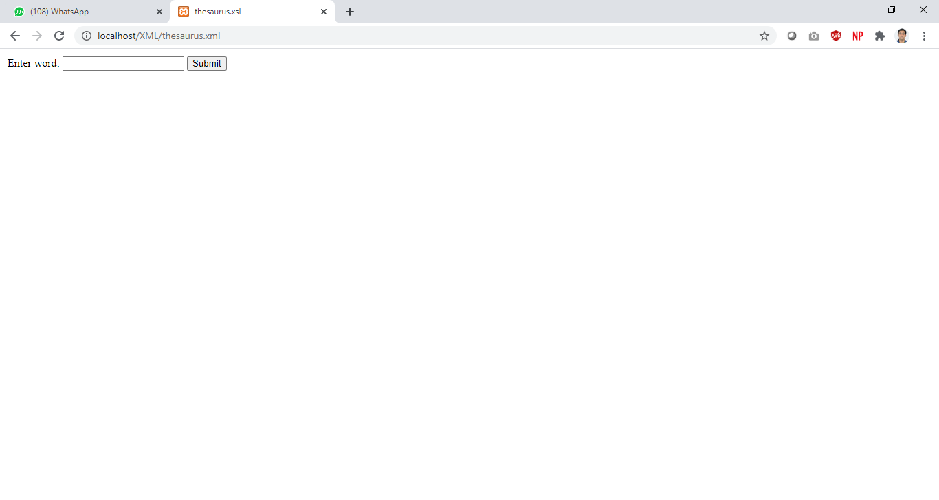

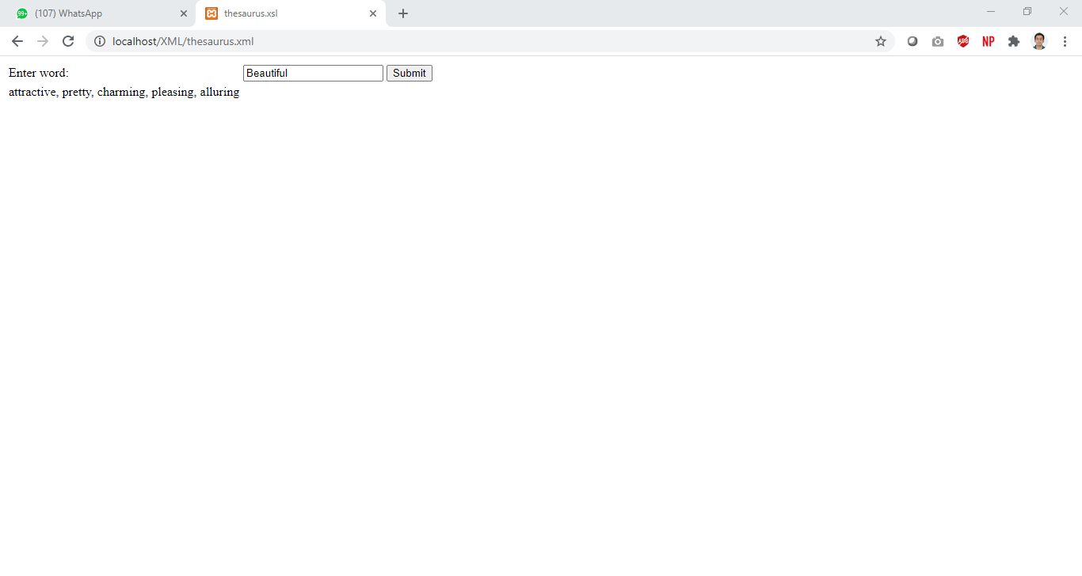

**Question:**

XSLT – Create a student mark maintenance system using XML. Create a webpage to display all the students consolidated mark statement with pass (green color) or fail (red color) using XSLT.

**Code:**

**sr.xml**

<?xml version="1.0" encoding="UTF-8"?>

<?xml-stylesheet type="text/xsl" href="sr.xsl"?>

<sr>

<student>

<n>Ishaan Ohri</n>

<m>100</m>

<res>PASS-Distinction</res>

</student>

<student>

<n>Shreya Basu</n>

<m>70</m>

<res>PASS-Very Good</res>

</student>

<student>

<n>Siddhant Sharda</n>

<m>01</m>

<res>FAIL-Better luck next time</res>

</student>

<student>

<n>Gurprasad Singh</n>

<m>88</m>

<res>PASS-Very good ,keep it up</res>

</student>

<student>

<n>Shivam Anand</n>

<m>33</m>

<res>FAIL-Better luck next time</res>

</student>

<student>

<n>Sameer Rupani</n>

<m>80</m>

<res>PASS-Very good ,keep it up</res>

</student>

<student>

<n>Rupin Singh</n>

<m>78</m>

<res>PASS-Very Good</res>

</student>

<student>

<n>Riya</n>

<m>50</m>

<res>PASS- Can do better</res>

</student>

</sr>

**sr.xsl**

<?xml version="1.0" encoding="UTF-8"?>

<xsl:stylesheet version="1.0"

xmlns:xsl="http://www.w3.org/1999/XSL/Transform">

<xsl:template match="/">

<html>

<body>

<h1 align="center"> STUDENTS' RESULT RECORD</h1>

<table border="4" align="center" width="500px" height="400px">

<tr>

<th>Name</th>

<th>Marks</th>

<th>Result</th>

</tr>

<xsl:for-each select="sr/student">

<xsl:if test = "m > 40">

<tr bgcolor = "green" align="center">

<td><xsl:value-of select="n"/></td>

<td><xsl:value-of select="m"/></td>

<td><xsl:value-of select="res"/></td>

</tr>

</xsl:if>

<xsl:if test = "m &lt; 40">

<tr bgcolor = "red" align="center">

<td><xsl:value-of select="n"/></td>

<td><xsl:value-of select="m"/></td>

<td><xsl:value-of select="res"/></td>

</tr>

</xsl:if>

</xsl:for-each>

</table>

</body>

</html>

</xsl:template>

</xsl:stylesheet>

**Output:**

